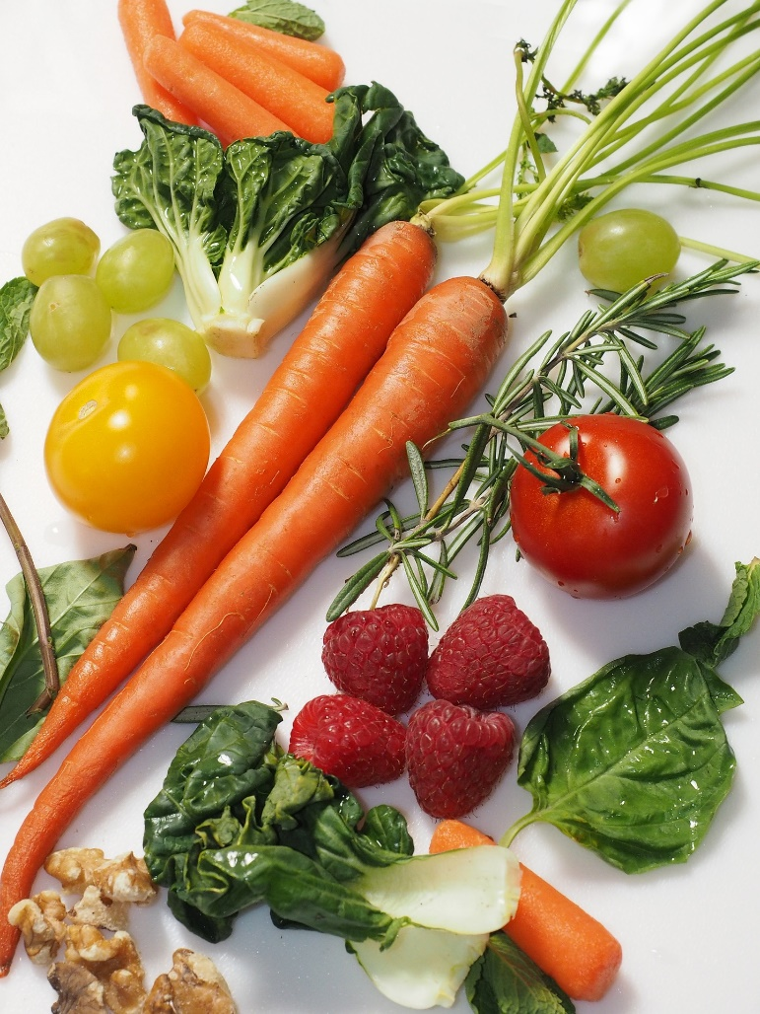

Jump Start to Health

By Cynthia Damaskos, CHHC
Certified Holistic Health Coach

www.holisticchristianlife.com
773-251-8161
The Study of Epigenetics
There is a false notion that the genes you are born with determine your health. The study of epigenetics continues to show us that it is our lifestyle that determines our health. As one doctor quotes “Our genes load the gun, but our lifestyle pulls the trigger.”
Even aging can be accelerated by an unhealthy lifestyle, effectively speeding up your rate of aging. Lack of quality nutrition, obesity, lack of exercise, psychological stress, toxins from food and environment, and smoking all cause production of free radicals that affect our telomeres and shortens them. Most age-related diseases can, in fact, be connected to telomere shortening.
So, what can you do to maintain optimal health, prevent, slow down and even reverse disease right now?

Here is your Jump Start to Health Guide!

The 5 components of a healthy day:
- Lifestyle Routine (Sleeping and Waking)
- Appropriate Diet
- Quality Supplementation
- Exercise
- Stress Management

We’ve grown up in a confused world
What we’ve been taught in the past has accelerated aging and disease. For the first time in history, our children are not projected to live longer than we do. Unfortunately, many conventionally trained doctors, dieticians, and other medical professionals are not up to speed with current nutritional science. To make matters worse, the FDA has not been able to protect us from harmful substances. How do you accurately implement the 5 components? We will take a look by describing the perfect day.

Daily Routine

Wake up at the same time each day
Start the day with your “Daily Ascesis” This is Holistic Christian Life’s term for a morning routine that involves the following:
Drink a room temperature glass of water with ¼ - ½ of a lemon squeezed into it.
Sit quietly, breathe deeply, and practice prayerful silence for at least 10 minutes.
Include your daily devotional and journaling
Stretching
Take a 30-minute walk outside
Breakfast

For breakfast, eat a meal that is high in protein, has Omega 3 fats, low carb and no sugar. I make a protein shake every morning with Garden of Life Raw Protein (unflavored), frozen blueberries, Dr. Axe’s Organic Greens, a handful of walnuts, a teaspoon of fish oil, and water. At times, I have an omelet using organic, free range eggs with plenty of organic veggies. You never want anything with sugar or refined flours in it for breakfast…unless you want to crash in the afternoon, and have trouble focusing and getting things done! That means no cereal, pancakes, toast…etc.

Start drinking your water for the day. Strive for ½ your body weight in ounces of clean, filtered water. I use a 30 oz thermos, knowing that I need to fill it at least twice.

For lunch and dinner, eat an appropriate meal (see below)

At the same time every day, 1 hour before your bedtime, begin your evening routine. Your bedtime is determined by setting what time you need to get up to do your Daily Ascesis, and get on with your day. Count back 7-9 hours depending on what you know you need. If you don’t know, start with 8 hours.
Example: I need to leave the house at 8am to get to work. My Daily Ascesis and personal hygiene take approximately 2 hours. Therefore, I must be up at 6am. To get up at 6am, I know I need to be asleep by 10pm since I need 8 hours of sleep. Therefore, I start my evening routine at 9pm.

- Stop looking at any screen, which includes television, computer, tablet, and phones. If you are using any of these devices excessively before the bedtime hour, consider buying blue-blocking glasses so that your hormones will regulate according to a healthy circadian rhythm.
- If you have trouble falling asleep, take a 10-minute bath with magnesium salts and a couple drops of lavender. Rinse off in the shower, as toxins will have been pulled from your body, and you want to rinse them off before they re-absorb. This is also good to do as a rule, as it helps rid your body of toxins.
- Evening prayers, gratitude journaling.
- Reading.
- Lights out when you cannot concentrate on reading any longer, or you have come to your sleep time. (10pm in the example above)

An Appropriate Meal – What does that mean?
Pure, clean, God created food doesn't come with a label. When we start messing with it however, the FDA gets involved and requires an ingredient list. I'm thankful for that! However, I'm not thankful that the FDA allows a lot of toxic junk in our food that has been connected to disease and even death. If you are reading this outside of the USA, you may be in much better shape than we are, since many of the ingredients in our food may have probably been banned in your country. Let's break down the offending categories.
- Preservatives. Preservatives kill bacteria. That's why they are added to food on our grocery store shelves. Their purpose is to extend shelf-life. The problem is, our bodies are made up of more bacteria (good) than cells. We are in fact, walking bacteria! What happens when we ingest bacteria killing preservatives? Exactly. We are killing ourselves. Sounds logical, right? Preservatives are the long words that are hard to pronounce. If you were to try to replicate the recipe in your kitchen, and you don't have a bottle of it in your kitchen, it's a "No buy." An imbalance of good to bad bacteria in your body affects your hormones, and also affects your sleep.
- Artificial Anything. Artificial means it's created with chemicals. In this case, chemicals that don't belong in a human body. Chemicals that don't belong in your body are foreign invaders that send your body into high alert. This creates inflammation, and inflammation has been found to be the root of disease. When your body is on attack, it doesn't want to sleep or produce energy.
- Glutamates...also known as Excitotoxins. Similar to artificial ingredients, these flavor enhancers are created in chemistry labs to create cravings and addiction to processed foods. They are toxic...sometimes even more so than artificial ingredients. However, they are allowed to sound healthy, like "Natural Flavors." Again, do you have a jar of Natural Flavors in your cupboard? No? It's a "No Buy." For a listing, and a deeper explanation, you can check out Dr. Russell Blaylock’s book “Excitotoxins, The Taste That Kills.”
- Added Sugar. When the low-fat fad began a couple decades ago (based on studies funded by the sugar industry,) sugar along with all of the above mentioned fake ingredients started to be added to virtually everything. The result? An increase in obesity and Diabetes. You cannot count on the numbers listed under Nutrition Facts, because they are typically in-accurate. Make sure you read the ingredient label. Sugar throws off your hormones, your microbiome, creates inflammation, pain, feeds cancer, and causes sleep disruption. This includes alcohol.
- Fats. Related to the low-fat mis-conception mentioned above, once traditional fats became the villain, poor quality fats started being produced. These include Canola Oil, Vegetable Oil, Soybean Oil, etc. Remember when people thought that Crisco and Margarine were good healthy alternatives? We know now that this was false. And yet...they are still on grocery store shelves. You want good fats at every meal, such as Olive Oil, Avocados, Walnuts, Coconut Oil, etc. Check out Dr. Mary Hyman’s website and his book “Eat Fat, Get Thin.” His information will help guide you deeper. Bad fats equal inflammation. Inflammation leads to disease. Good fats feed your brain cells, balance your hormones and your blood sugar.
- GMO's. The purpose behind Genetically Modified food is to yield larger crops by making the plants hardier. Sounds good, right? Problem is, the way they are made to be hardier is to enable them to be sprayed with toxic chemicals that kill the weeds around them, but keep the crop living. This seems scary doesn't it? The dandelion is dead, but the corn stock lives on. These products are bred with the toxins in their DNA so to speak. That ends up in you. This happens when it's directly from the plant, or the meat or dairy from the animal that was fed the plant, since toxins are stored in an animal’s fat. Despite claims by the chemical companies to the contrary...they are finding these toxins in people during autopsies. Here is my rule of thumb. Did God create it that way? No? Then it doesn't belong in my body.
- Organic. Yes, I know it can be expensive, but don't let this discourage you. First, if you are on a budget, go to the Environmental Working Group (EWG.org) website and check out their Dirty Dozen and Clean Fifteen list. Make sure you buy the Dirty Dozen in organic, and for the rest, soak or spray with a mixture of 1/3 vinegar to 2/3 water. This will get rid of 98% of the pesticides on the outside of the produce at least.

Does this sound daunting? Here is a rule of thumb:
Your plate should be filled ½ way with organic raw vegetables. A healthy dressing would be olive oil/vinegar/pepper/garlic/and an herb such as oregano.
¼ should be a high-quality protein like organic grass-fed beef, organic free-range chicken, wild caught fish, etc.
¼ should be a complex carb or cooked veggie such as a sweet potato, broccoli, etc.
You want at least one good fat with each meal. It can be an oil, an avocado, nuts or seeds.
If you are buying food with labels, here is an easy tip:
If you can’t replicate the “recipe” at home, you shouldn’t buy it.

A few important foods to include:
Garlic to protect against cancer, improve blood flow to the heart, and prevent plaque buildup. Best if fresh (raw) and crushed.
Chlorella for brain health, concentration, increased energy, normalized blood sugar and blood pressure. It can help make up for a poor diet and lifestyle and improve skin appearance.
Blueberries to relieve arthritis symptoms, fight free-radicals, prevent brain aging, improve vision, and reduce cholesterol.
Broccoli reduces cancer risk
Leafy Greens support stronger bones, fights cancer risk, prevention of Alzheimer’s, regulation of insulin.
Raw, Organic, Free Range Eggs (not Omega 3 enhanced) for the highest source of quality protein, 9 amino acids, eye health, brain health.
Quality Supplementation
You may ask, why do I need to supplement if I’m eating right? Can’t I get all of my nutrients from food? The sad state of our food and our soils mean that our food just isn’t as nutrient rich as it once was. Add on a compromised gut that comes from eating a bad diet along with toxins, and the average person is just not absorbing nutrients like they should.
Be careful about the supplements you buy. Cheap supplements are made with synthetic vitamins that can go right through you without any benefit, and may even cause damage. Folic Acid is an example. You do not want to take Folic Acid, as it is synthetic, and can cause harm. What you want is Folate instead. Make sure you buy quality brands that are based on whole foods and preferably raw.
I recommend testing by a knowledgeable Functional Medicine Doctor, Integrative Medicine Doctor or Naturopath, but here are some supplements most people find they need:
Magnesium (Best found in Glycinate to do damage control caused by stress)
Fish Oil
For bone health - Magnesium/K2/D3/Calcium
Probiotic
D3

Exercise
A 30 minute walk daily, some weight training 2-3 times a week, and some interval training on those same days is all you need. People who are “busting it” at the gym are often doing more harm to their bodies than good by increasing physical stress. Physical stress as well as stress from emotions, a bad diet, and lack of sleep are all contributors to poor health. At a minimum, your morning walk can have a big impact on your health.

Stress Management
When we are not managing our stress well, our adrenal glands and thyroid have to work overtime which can lead to health issues through hormone disruption. Our gut microbiome is affected, as is our brain and our heart. Stress contributes to inflammation.
During your Daily Ascesis, at least 10 minutes of prayerful silence was suggested. This is a time when you focus on deep belly breathing and listen for God’s voice. In our crazy, overactive world, how often do you just sit in silence and listen? This can be tough at first, but think of it as a muscle that needs to be strengthened with discipline. It gets easier as you go along, and yields great results. This practice, as studied in the eastern religion and secular world of meditation, has shown to reduce stress throughout the day, and even helps you sleep better at night. Look up Dr. Andrew Weil’s website for the breathing techniques that he teaches.

The Daily Ascesis as a whole sets you up for a day of well managed stress. Eating properly, exercising regularly…but not in excess, and sleeping well also manage stress from all sources.

I hope you have a clear and easy understanding now of how to jump start your health. I have not touched on lifestyle choices such as smoking, drinking alcohol, drinking sodas, etc. I’ve found that most people know when they have unhealthy habits, and breaking them is the key. One way is to crowd out the bad behavior by implementing everything that is good. Another is to work with a health coach who will come along side you and be your guide. This resource is the tip of the iceberg...but the good news is…just doing these simple things will get you on your way in no time!

